1. Use Case Diagram
The Use Case Diagram shows the interaction between users and the Hospital Management System. The main actors are Patient, Doctor, Receptionist, Pharmacist, Billing Staff, and Administrator. Patients can register, book appointments, and view medical reports. Doctors diagnose patients and prescribe medicines. Receptionists manage appointments and billing. Pharmacists issue medicines, while administrators manage staff information.
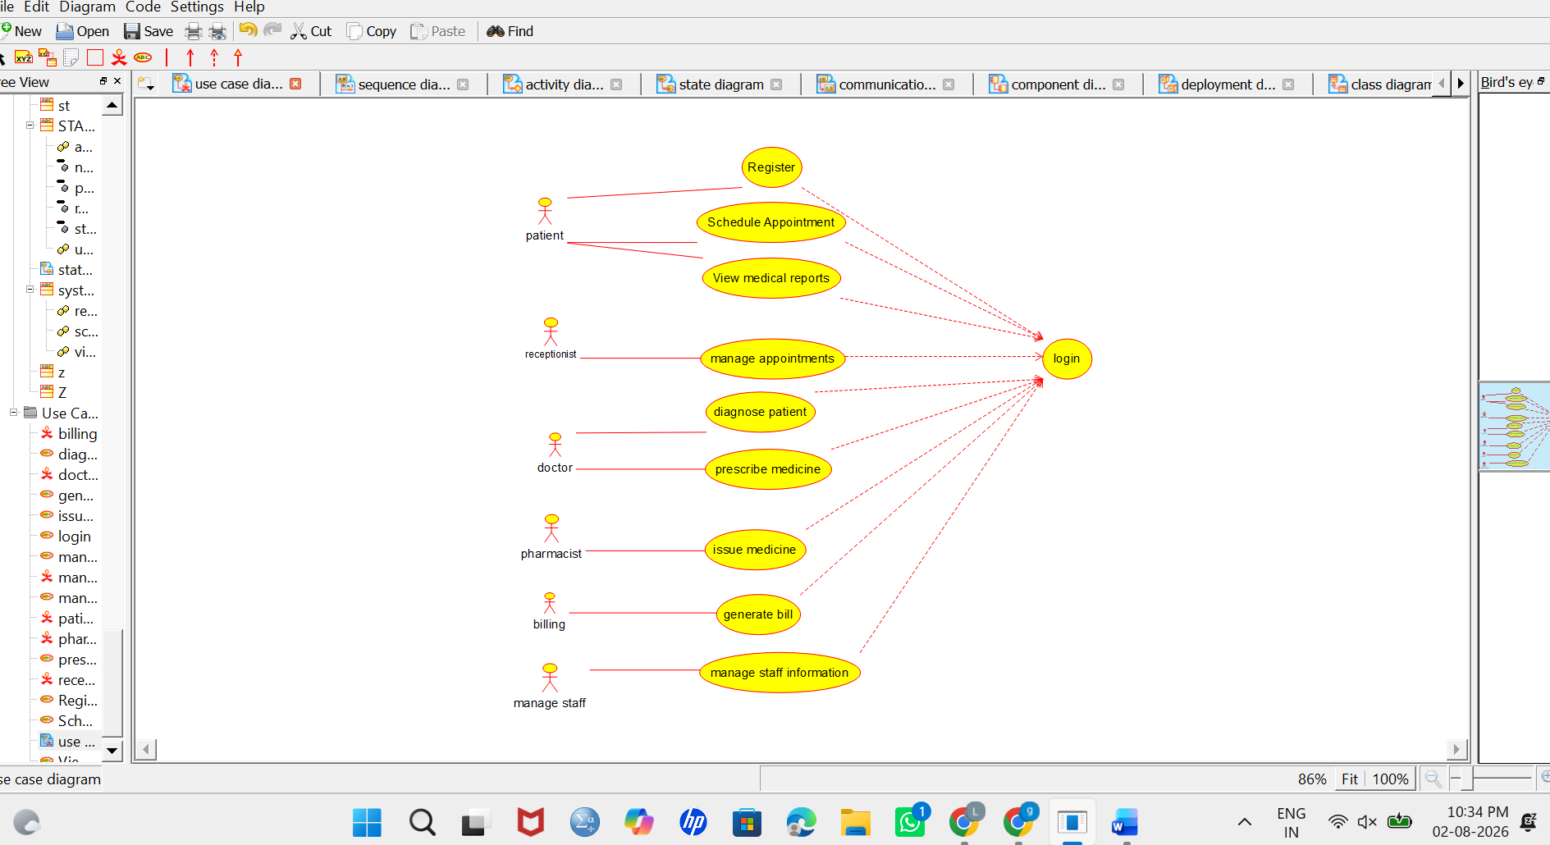

2. Class Diagram
The Class Diagram shows the static structure of the Hospital Management System. Important classes include Patient, Doctor, Appointment, Department, Medical History, Prescription, Medicine, Bill, Pharmacist, Receptionist, and Administrator. Each class contains attributes and methods. The relationships show how patients, doctors, appointments, prescriptions, and bills are connected.
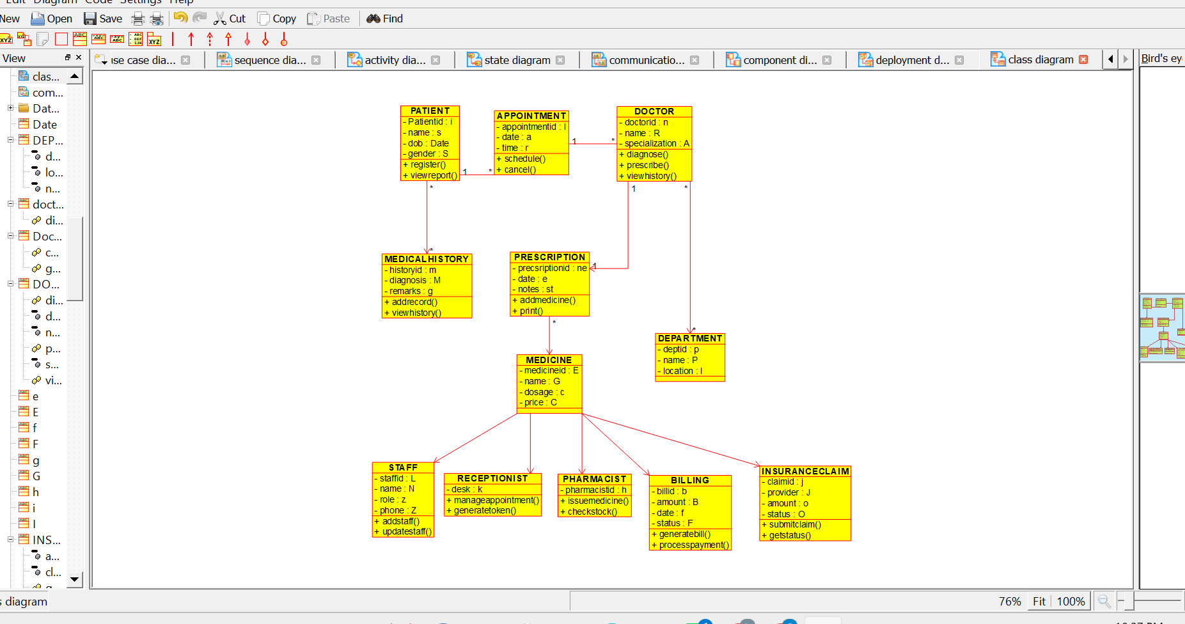

3. Object Diagram
The Object Diagram represents a real-time example of objects in the Hospital Management System. For example, a patient named Ravi, a doctor named Dr. Kumar, and an appointment can be shown as objects. It displays the actual values of attributes and the relationships between objects at a particular time.
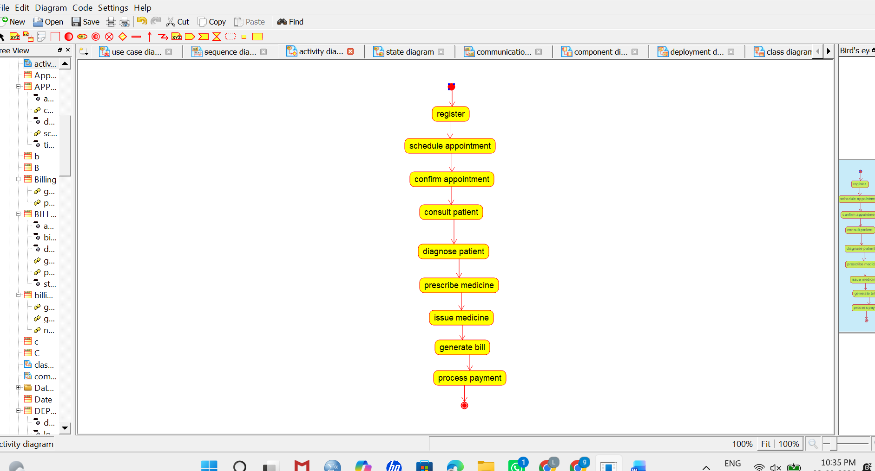
4. Sequence Diagram
The Sequence Diagram shows the order of interactions between objects. A patient registers and books an appointment. The receptionist confirms the appointment, and the doctor examines the patient. The doctor creates a prescription, the pharmacist issues medicines, and the billing department generates the bill. It explains how messages are exchanged step by step.
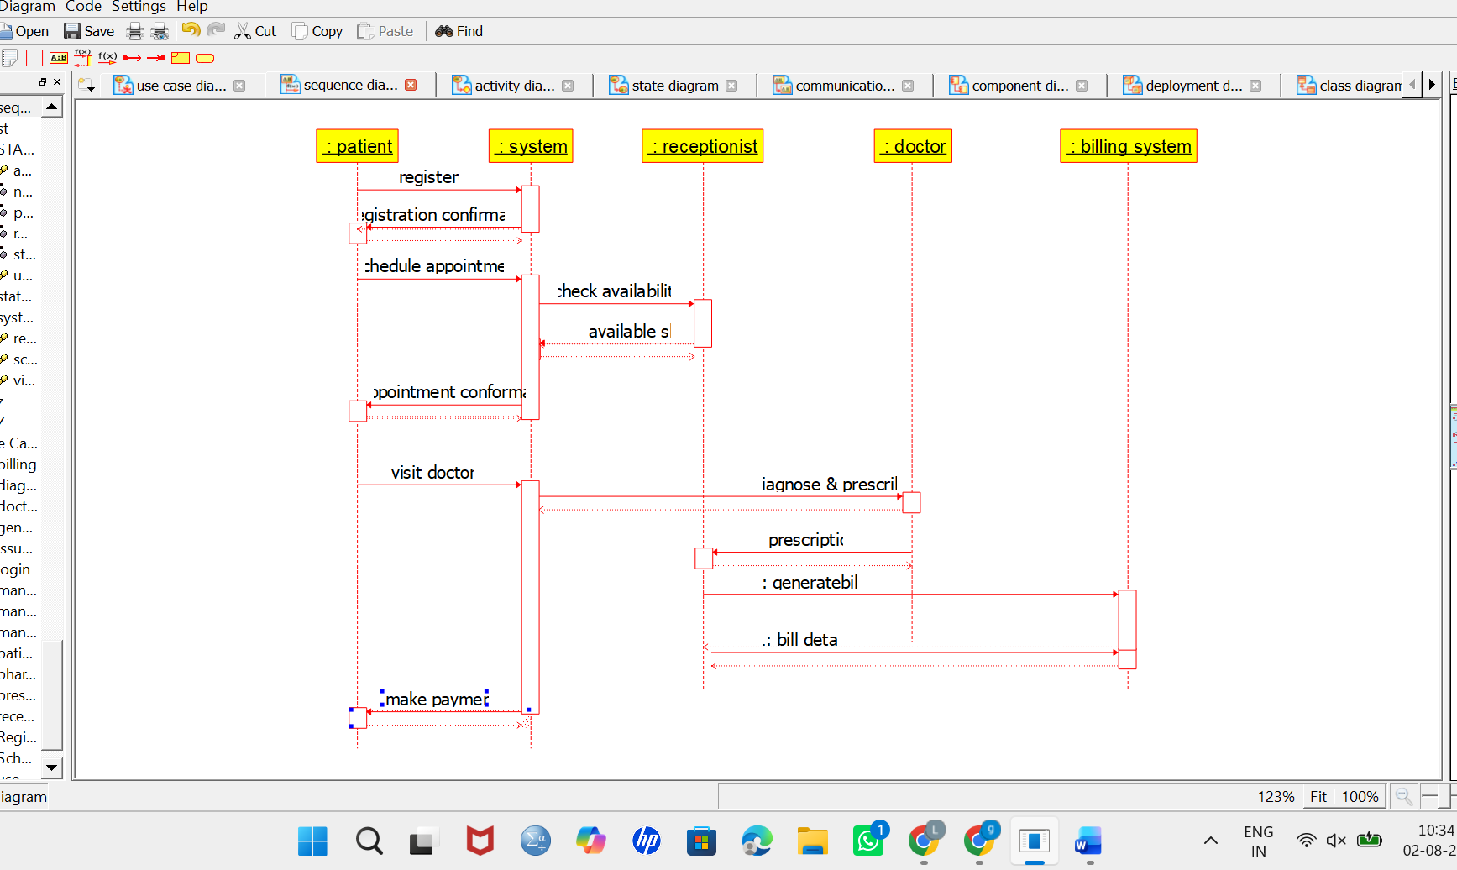

5. Activity Diagram
The Activity Diagram shows the workflow of hospital operations. The process starts when a patient registers and schedules an appointment. The patient then meets the doctor for diagnosis and treatment. After the doctor provides a prescription, medicines are issued, and the billing process is completed. The activity ends after payment and report generation.
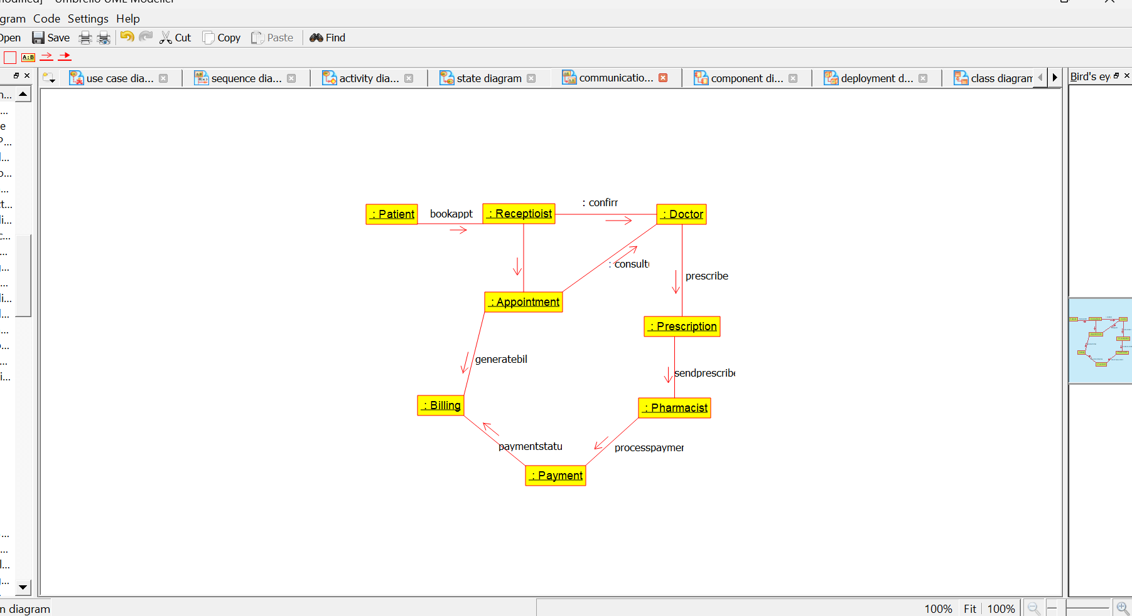
6. State Machine Diagram
The State Machine Diagram shows the different states of an appointment or patient record. An appointment may move through states such as Scheduled → Confirmed → In Progress → Completed → Cancelled. It explains how the state changes based on different events and actions.
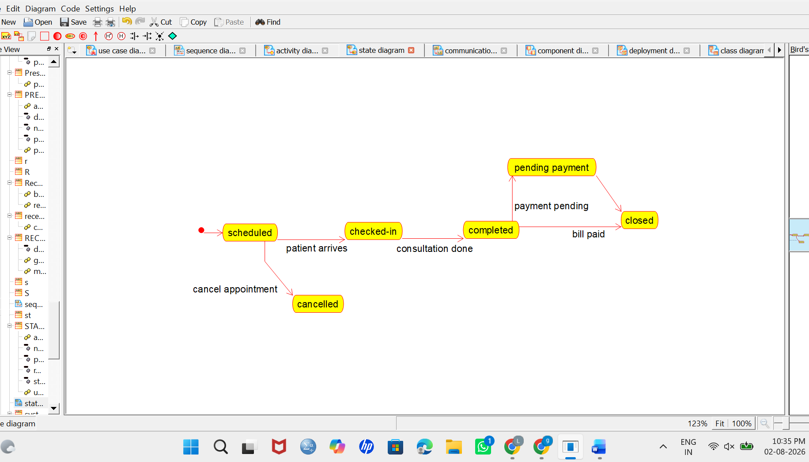

7. Component Diagram
The Component Diagram shows the major software components of the Hospital Management System. Components may include Patient Management, Appointment Management, Doctor Management, Medical Records, Pharmacy Management, Billing and Insurance, and Staff Management. These components communicate with each other to provide hospital services.
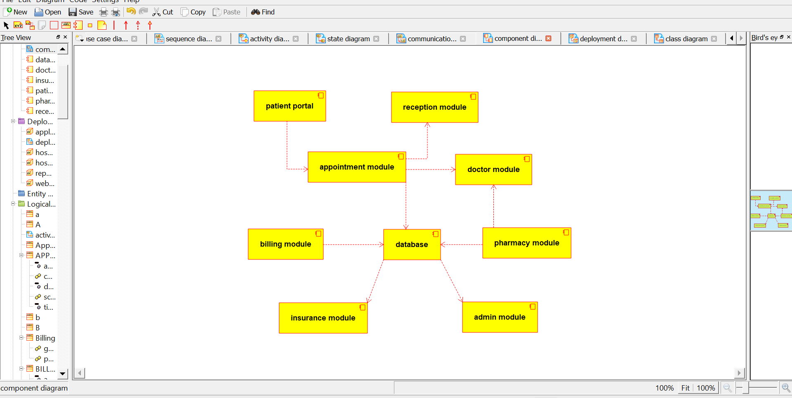

8. Deployment Diagram
The Deployment Diagram shows how the Hospital Management System is deployed on hardware. Users access the system through computers or mobile devices. The application runs on a hospital server and connects to a central database server. Different departments, such as reception, pharmacy, billing, and administration, access the system through the hospital network.
